Java Backend Interview Assignment TEST CASES:

1. **Create a Java Spring Boot Application.**

I created [**Assignment_API_CALL**](https://github.com/jayaseelan94/Assignment_API_CALL) spring boot project is created and committed in GITHUB.

You can check below link : https://github.com/jayaseelan94/Assignment_API_CALL

2. Project Structure is required for ease of maintainability and readability.

Yes created with same structures.

3. Explore api for Client (Example: to be test via Postman. Please provide the Postman Collection.)

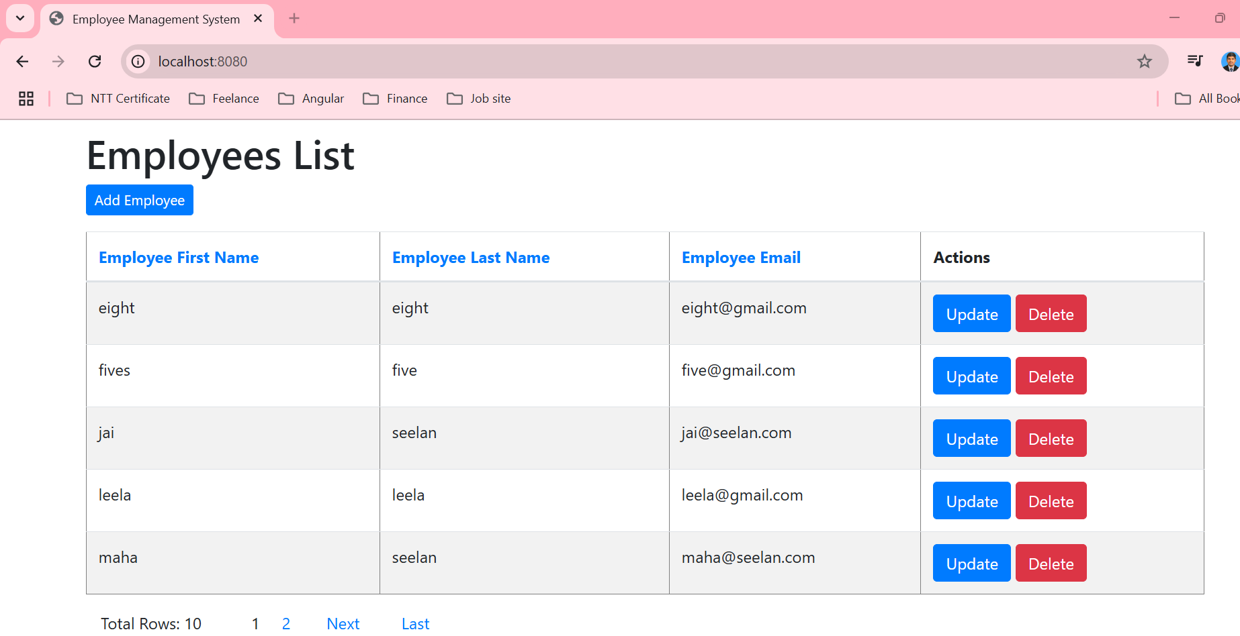

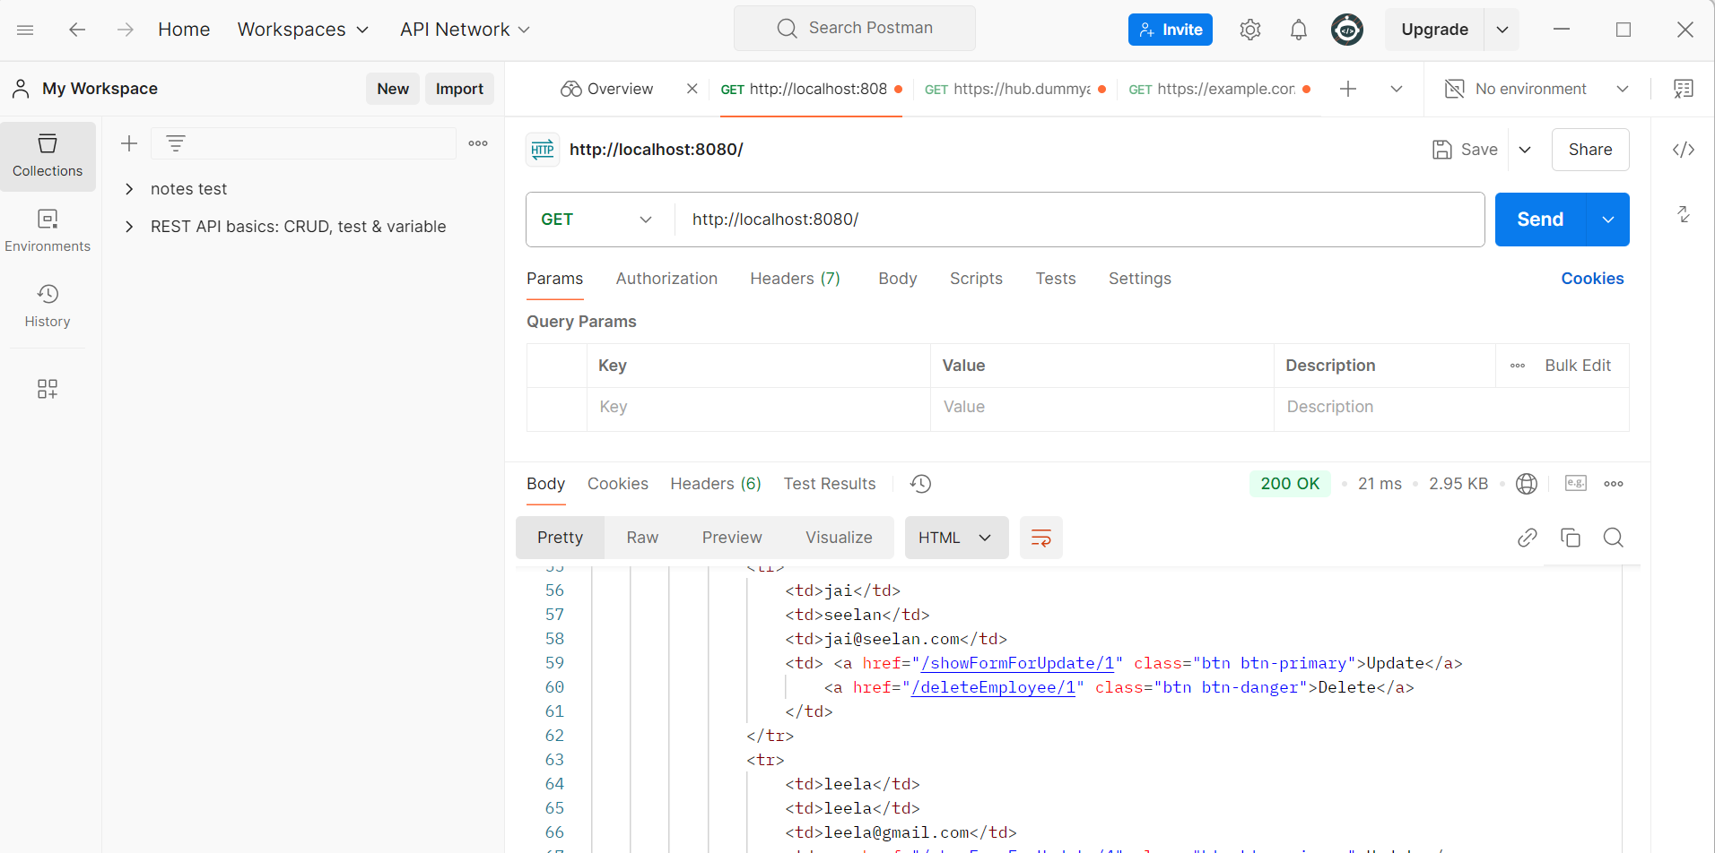

4. Each api required to log REQUEST & RESPONSE info into logs file.

5. Your project able connect to database, preferred with MSSQL database (Using Local Machine DB, DB name: TESTDB).

- @transactional is required implement in the project. (For http Methos: INSERT, UPDATE, GET method)

Completed:

INSERTION -> POST, Update , Delete and listing did and refer below screenshot.

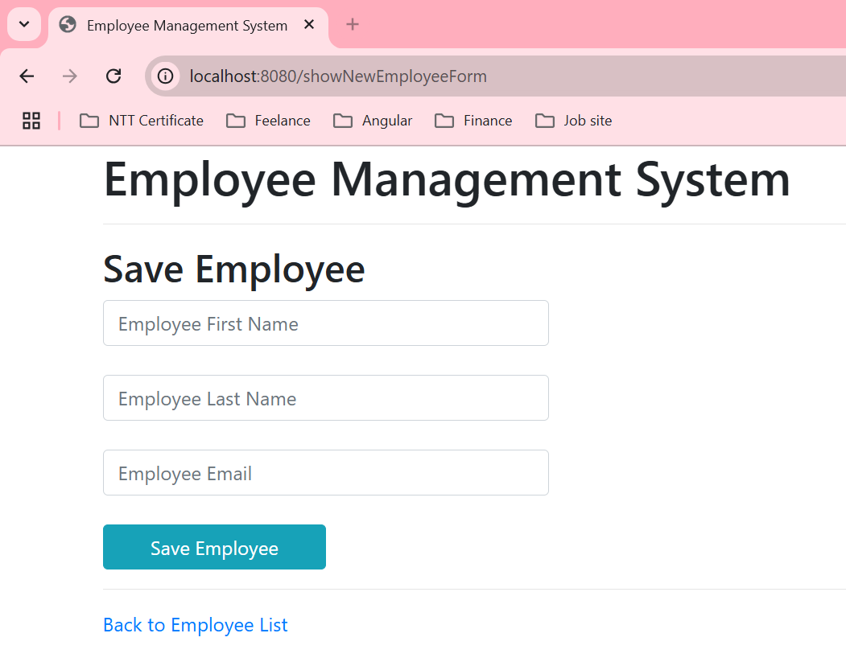

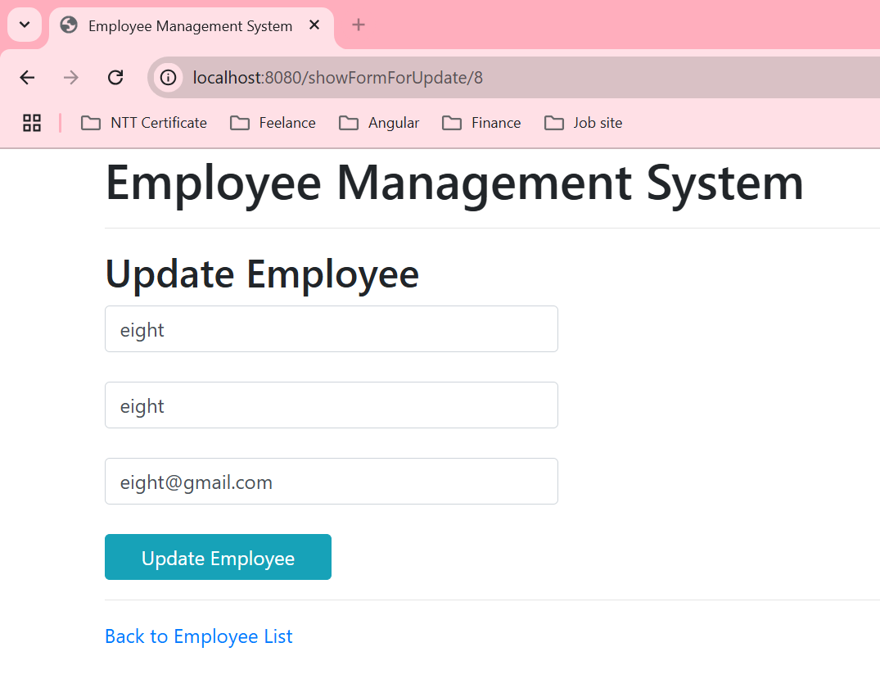

6. Explore 1 GET method api with Pagination (Each Page 10 records)

Pagination added below table: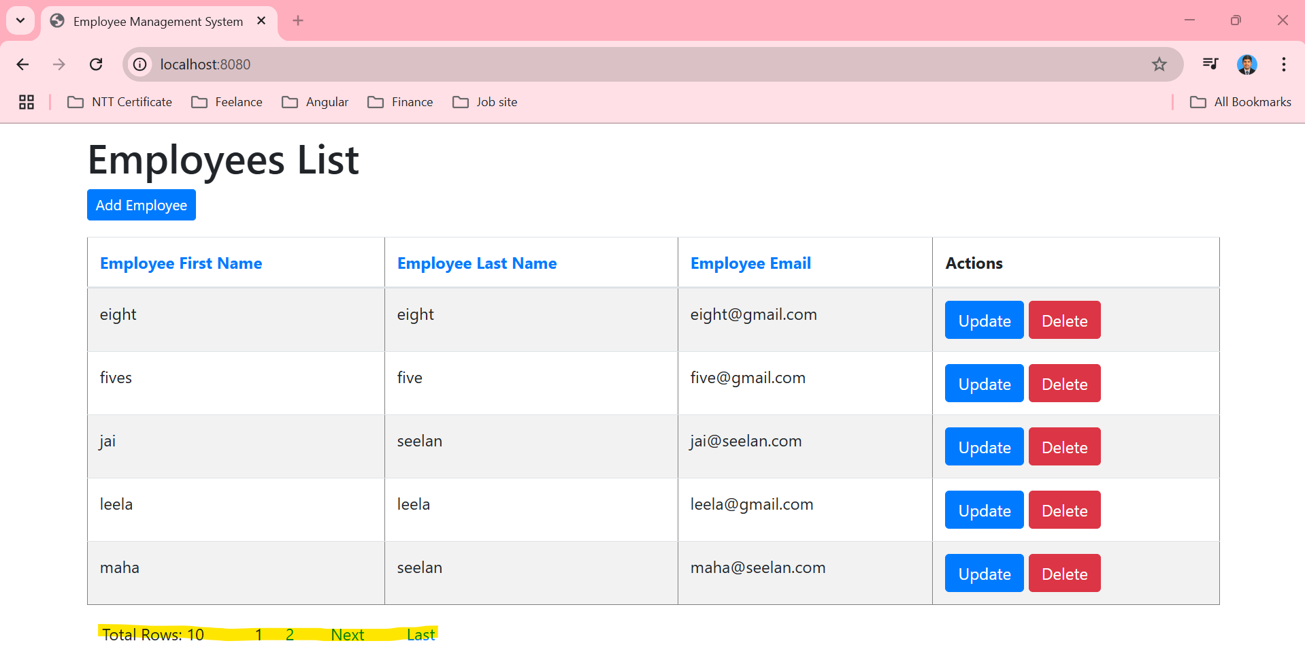

7. Explore an api which will nested calling another api from 3rd party.

Example: Postman/Client > Your API Endpoint > calling another api

Completed:

Third Party api calling From My @Restcontroller to https: josnplaceholder dummy API third party To display.

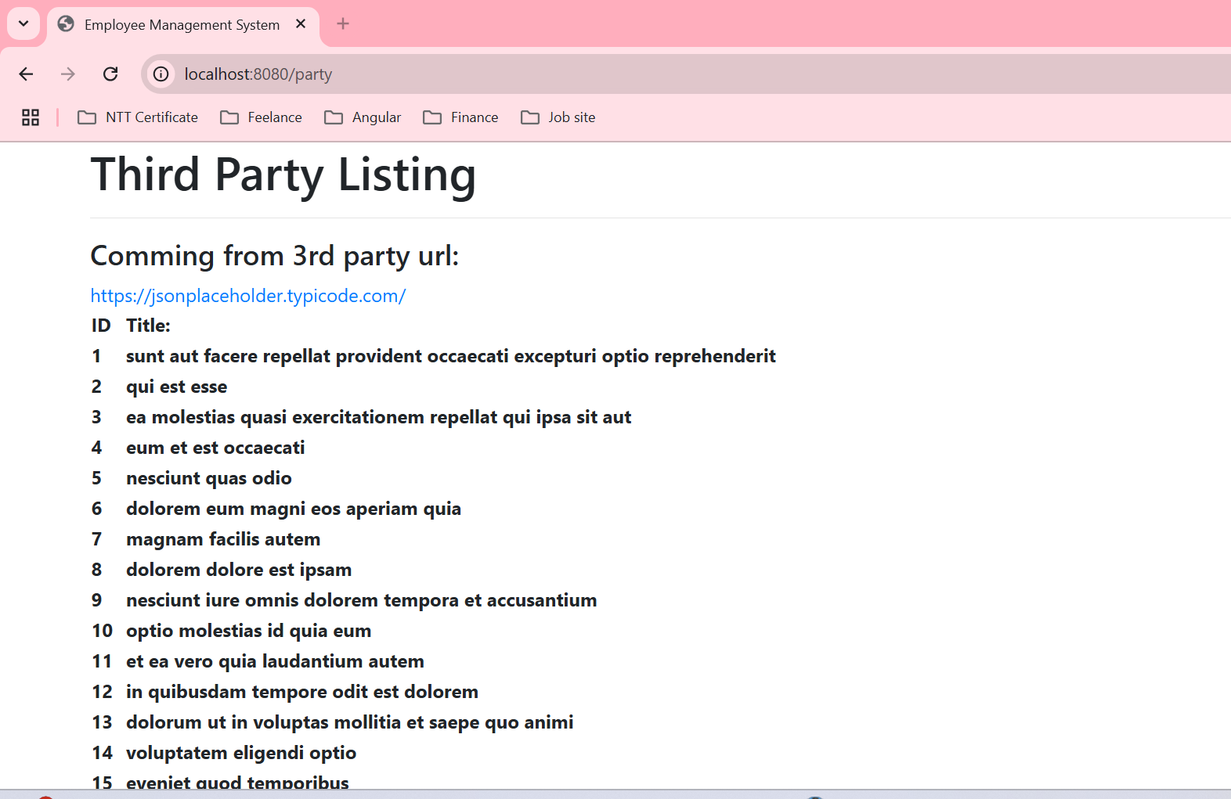

You are able to upload the assignment to a public git folder and share the URL for us to review.

Optional: Do include unit test for your service